GUMUDAVELLI THRUSHITHA
2303A54058 B-47B
Lab 1
Assignment Number 1.3
TASK:1
PROMPT: Write a Python program that asks the user for a number and prints the Fibonacci sequence up to that number, without using any functions 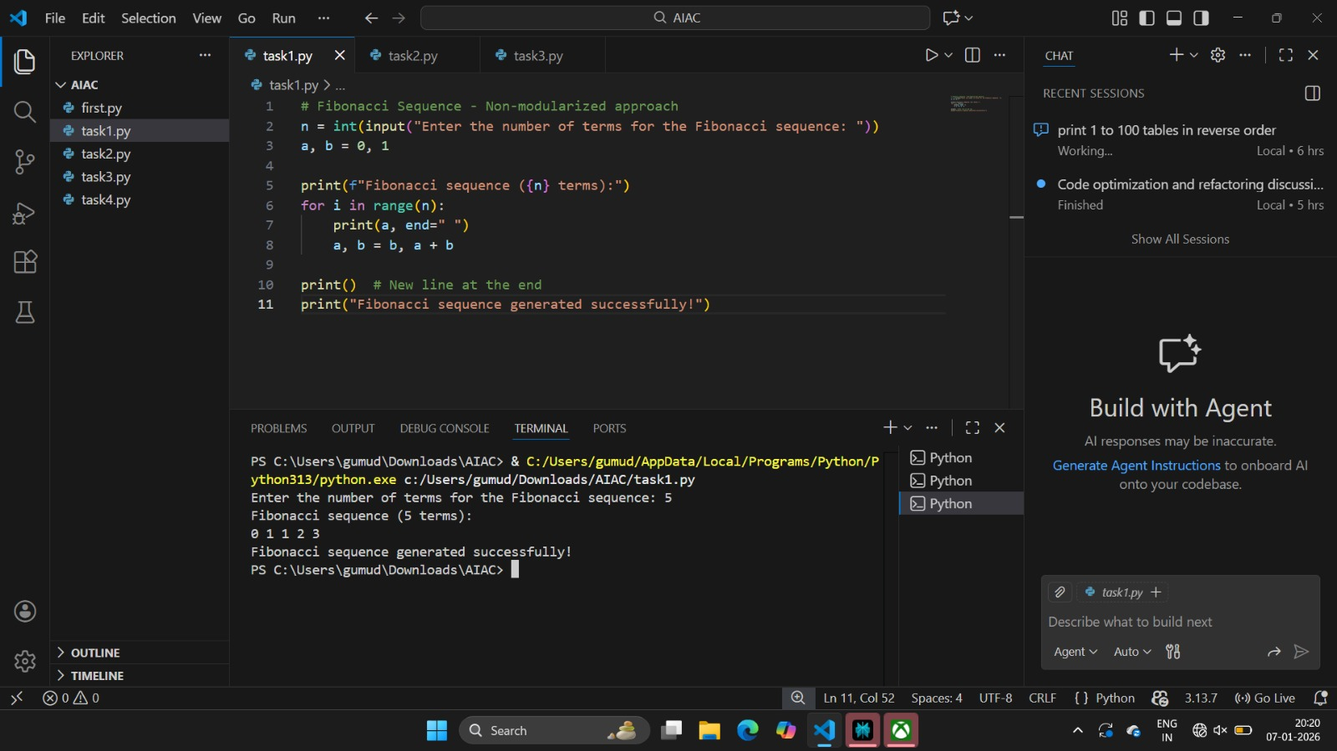

TASK:2
PROMPT: Optimize this code
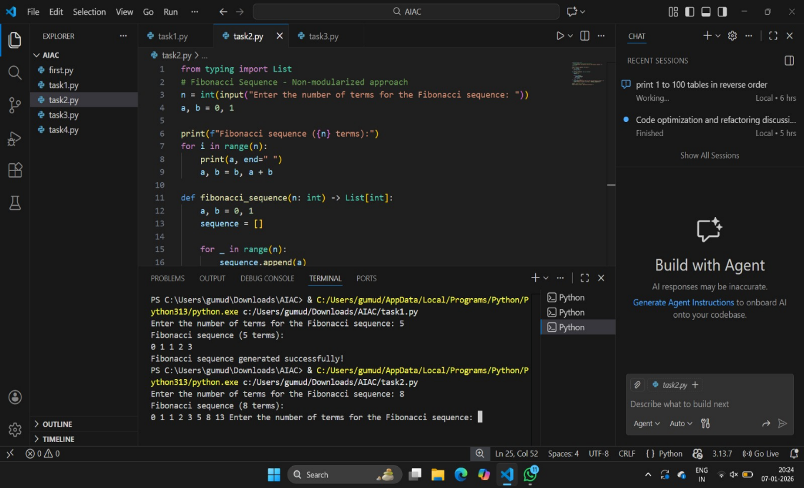
TASK:3
PROMPT: Write a Python program that uses a function to print the Fibonacci sequence and asks the user for a number
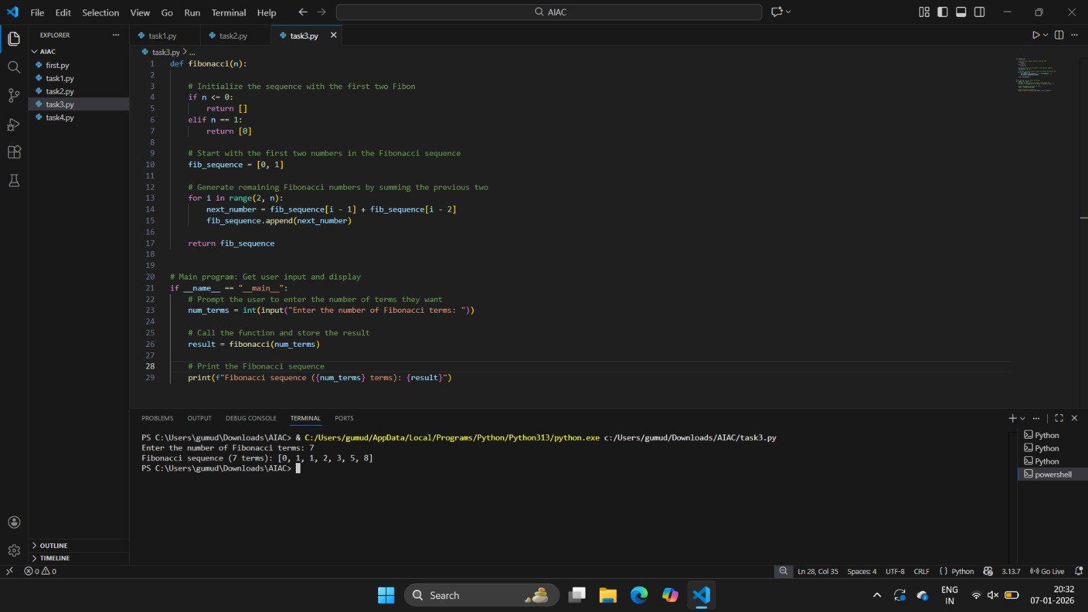
TASK:4
PROMPT: Print Fibonacci code with functions and without functions
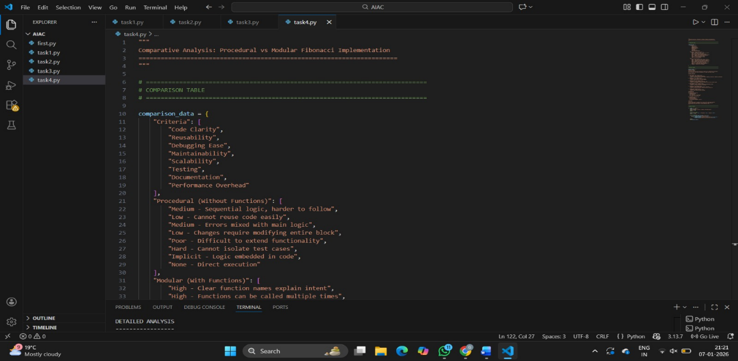
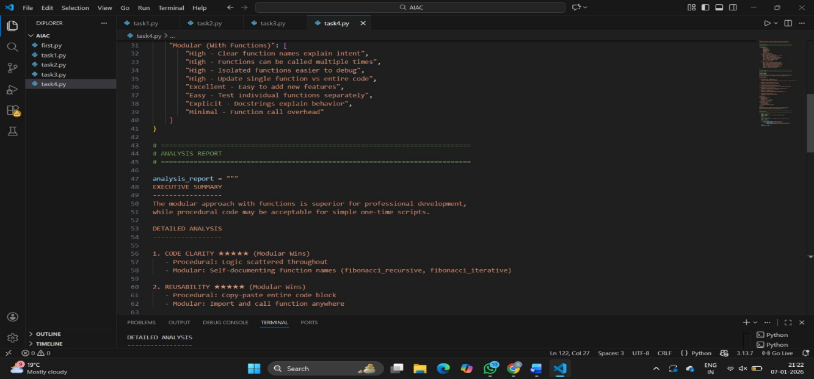
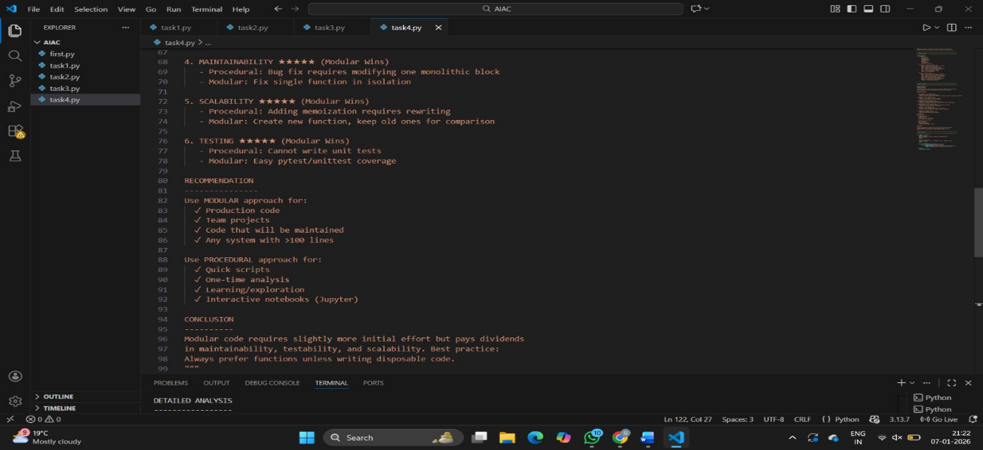
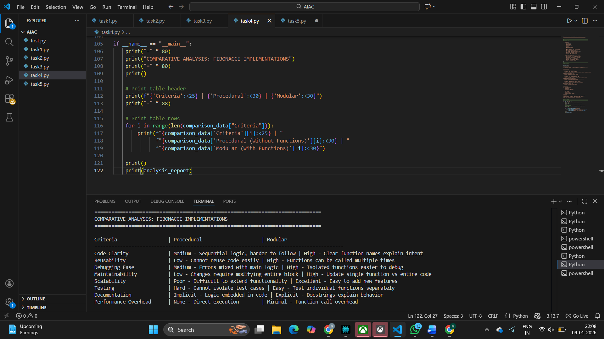

TASK:5
PROMPT: Generate an iterative Fibonacci implementation, recursive Fibonacci implementation compare their time complexity, performance for large n
